**Case Study On**

**Surface Mount Technology at Chromalox Instruments and Control Corporation**

**Group No. 5**

**Anant Adhvaryu**

**Anisha Ganeshkumar**

**Chaitali Pawar**

**Abstract:** -

In Chromalox Corporation, management decided to introduce 1/16DIN controller in the market. For that reason, they need to choose from two alternative 1) In-house production 2) Sub-contracting method. Finally, they will decide based on PW and IRR method that which method is feasible for production.

**BACKGROUND: -**

A 1/16 DIN controller goes through various manufacturing process. The two alternatives available are

**a) In-house production**

Purchase the equipment needed to perform the surface mount assembly process in-house. Chromalox would be able to utilize equipment currently available for the hand insertion, wave soldering, and board-level testing steps in the manufacturing process, assuming no capacity constraints. This equipment would need no additional maintenance or working capital but would require additional programming and setup.

**b) Sub-Contracting**

Subcontract the circuit board assembly process to an assembly house. Chromalox would continue to purchase all materials, kit the materials for the jobs, and forward the kits to the subcontractor. The subcontractor would install surface mount and through-hole components to the boards and perform a visual inspection inspection chromalox would continue to test electrically. Rework would be performed at chromalox for minor repairs or at the subcontractor for major repairs.

**PART I**

**AFTER TAX ANALYSIS**

Economic comparison based on most-likely estimates Base your first analysis is on the most-likely forecasted demand of the 1/16 DIN controller. Use the cost of materials, labor, and overhead from the history of the most similar 1/4 DIN controller with the exceptions previously noted. Find the PW at a MARR of 20% for the in-house production alternative and the subcontract alternative. You will need to create tables, including revenues, expenses, taxes, depreciation, and investment. For the subcontract alternative, remember the inventory carrying cost and tooling costs. Also find the IRR for both alternatives. Which alternative is preferred?

**(* Disclaimer: some of the snips of Excel are not clear enough, so the Excel workbook of this case study containing all the analysis is uploaded on google sheets and access has been given to Professor as well as TA. Link of the google sheet is inserted below* )**

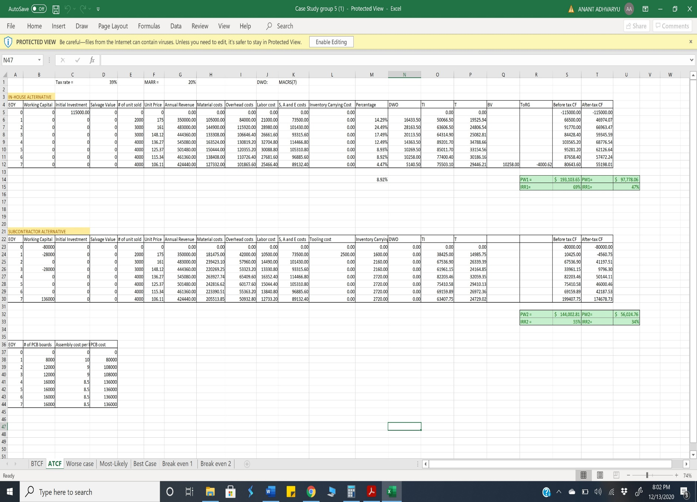

**Result:** After getting results of PW and IRR from the In-hose and sub-contractor alternative, we found that In house alternative is more feasible option then Sub contracting alternative because PW and IRR are greater.

**PART II**

**SENSITIVITY ANALYSIS**

Sensitivity analysis is a financial model that determines how target variables are affected based on changes in other variables known as **input** variables.

Although we have a higher demand of the 1/16 DIN Controller, sensitivity analysis is suggested to assess the 3 possible scenarios

* Best case
* Worst case
* Most-Likely

**Best case:**

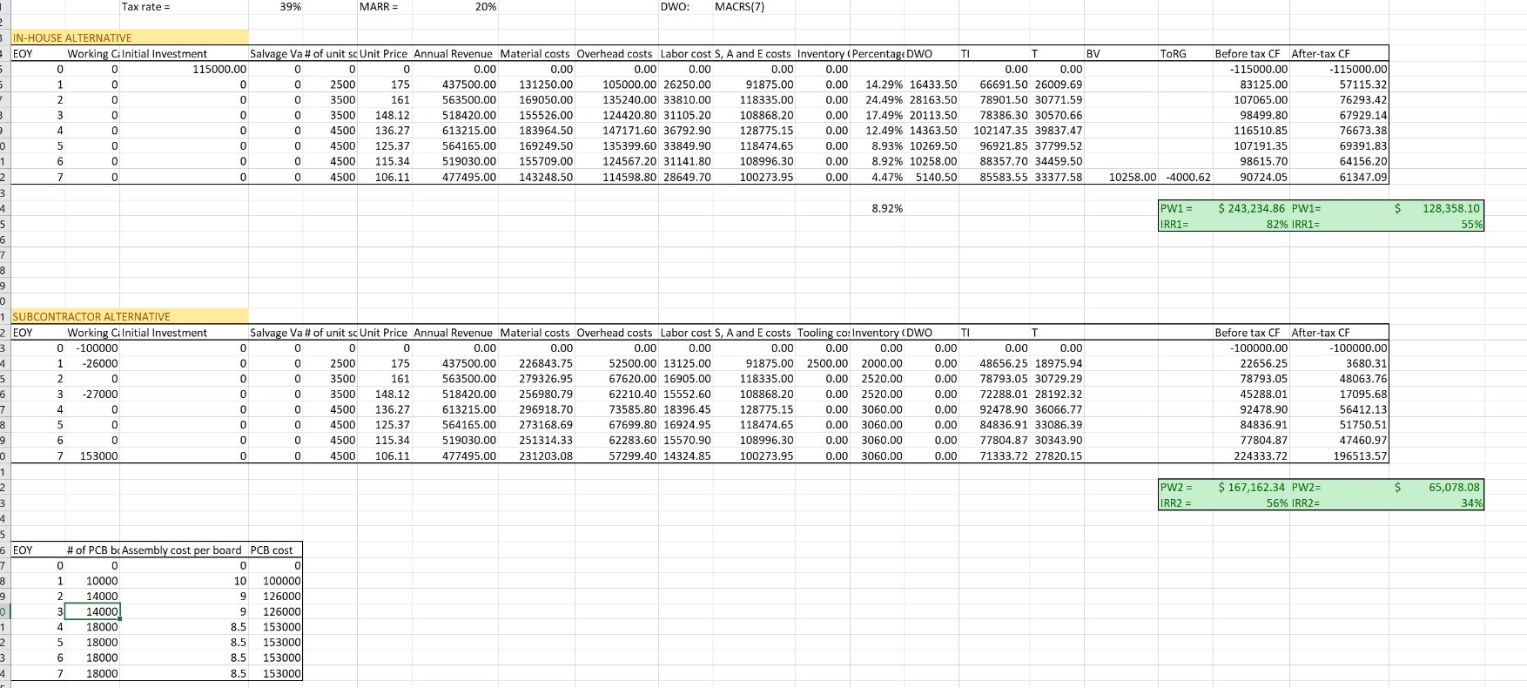

**Result:** After evaluating the Best Case, In-House option is suitable due to PW and IRR is more than Sub-Contracting option.

**Worst case:**

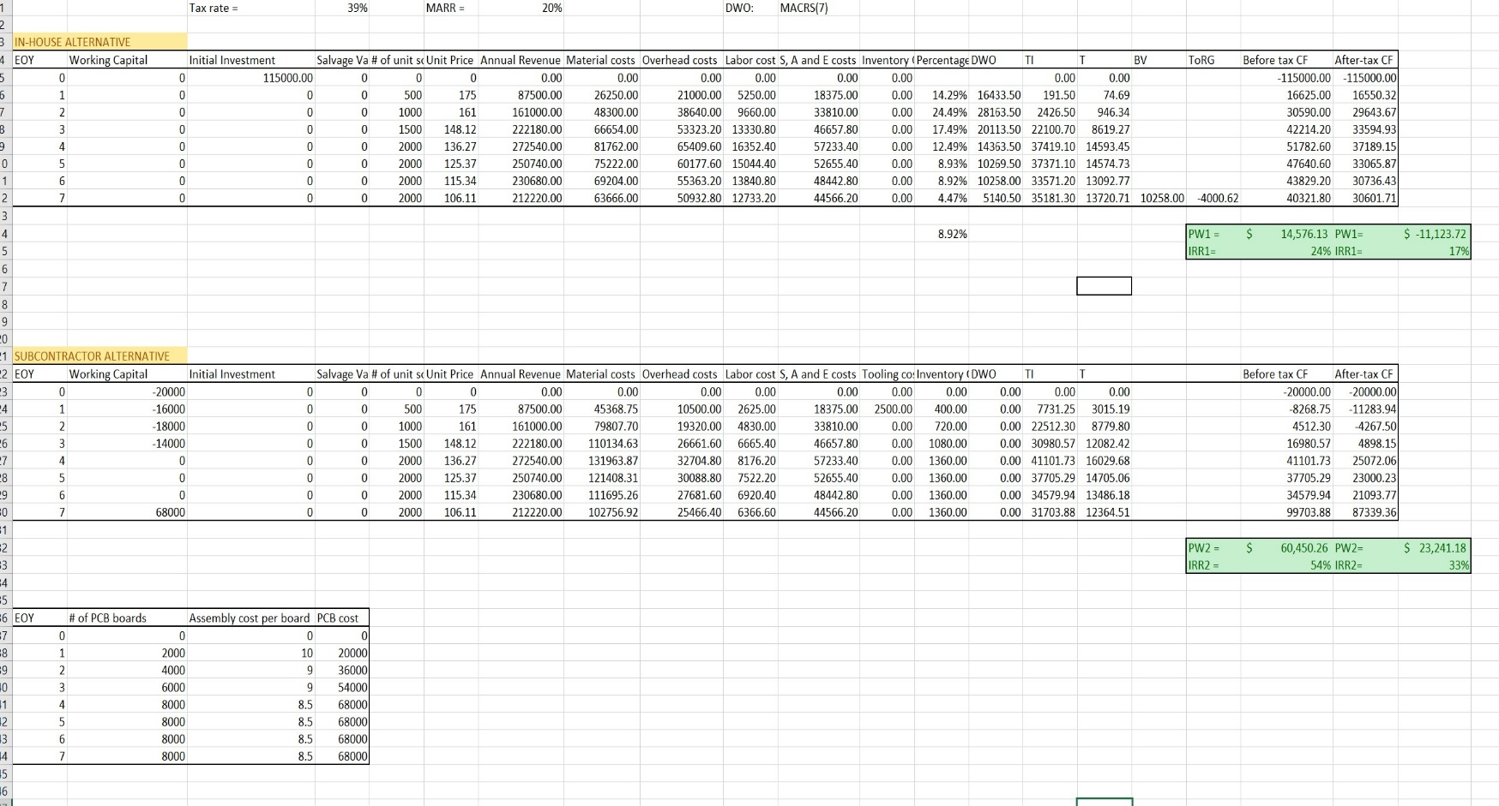

**Result:** After evaluating the worse Case, Sub-contracting option is suitable due to PW and IRR is more than In-house option.

**Most Likely:**

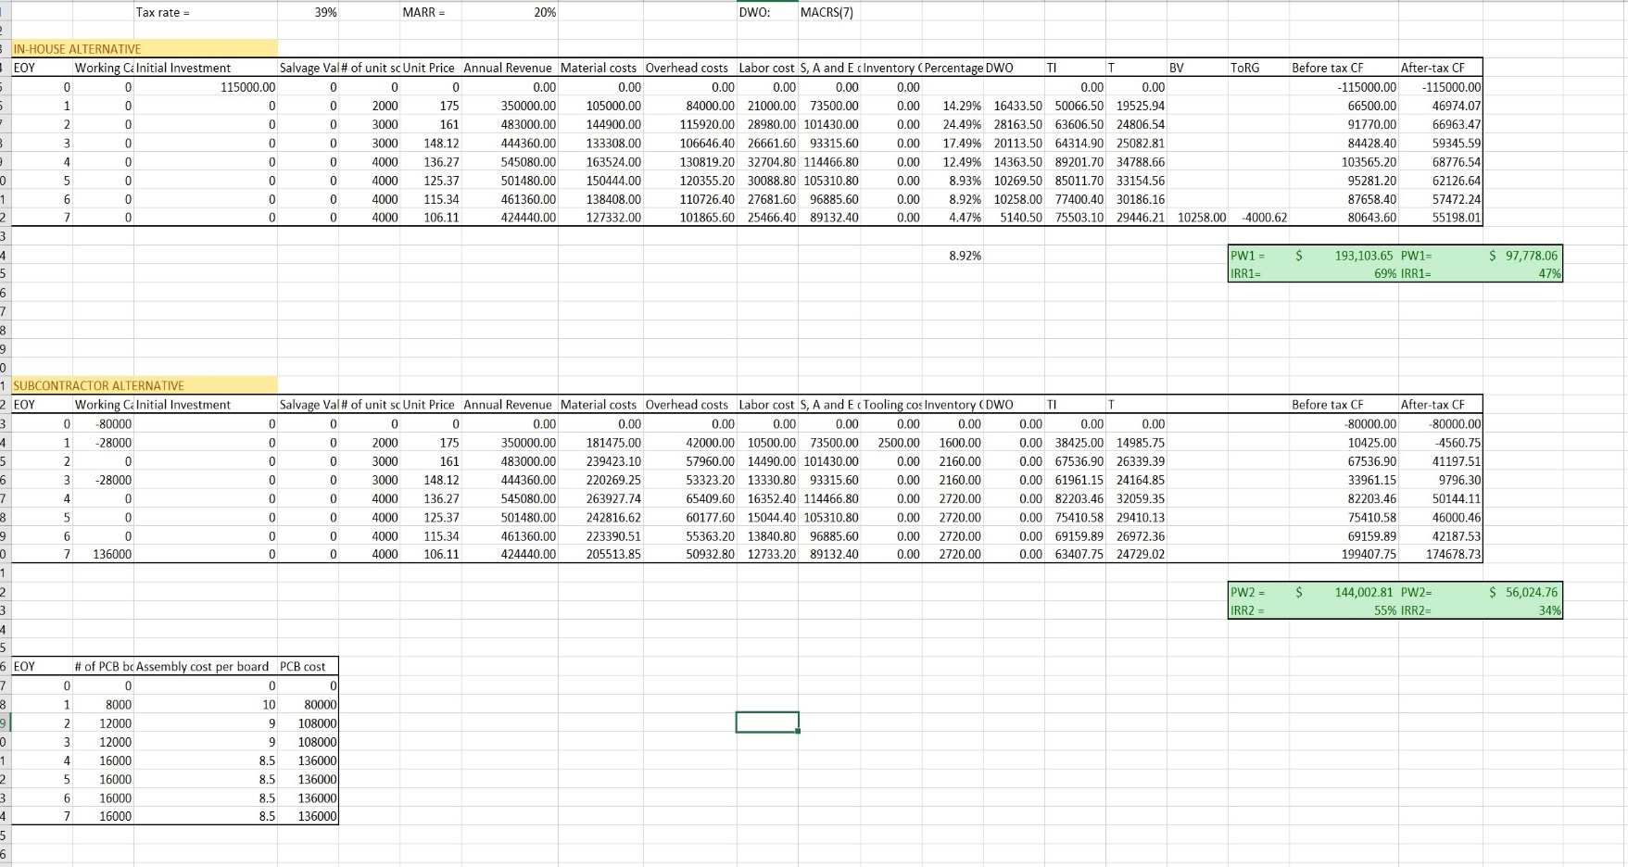

**Result:** After evaluating the Best Case, In-House option is suitable due to PW and IRR is more than Sub-Contracting option.

**Sensitivity Analysis Conclusion:** From all three scenarios, we are suggesting that in best and most-likely case we can choose in-house production while in Worse case we can select Sub-contracting option. However, If we want to play on safe side then we can choose subcontracting alternative because IRR of both Worse case and best case doesn’t deviate much from most likely, making it more reliable and less risky.

**PART III**

**BREAK EVEN ANALYSIS**

1.Suppose that Chromalox did not have sufficient assembly capacity to produce the 1/16 DIN internally. Determine the maximum level of capacity expansion (in dollar terms) required to make the in-house option equivalent to the subcontracting option.

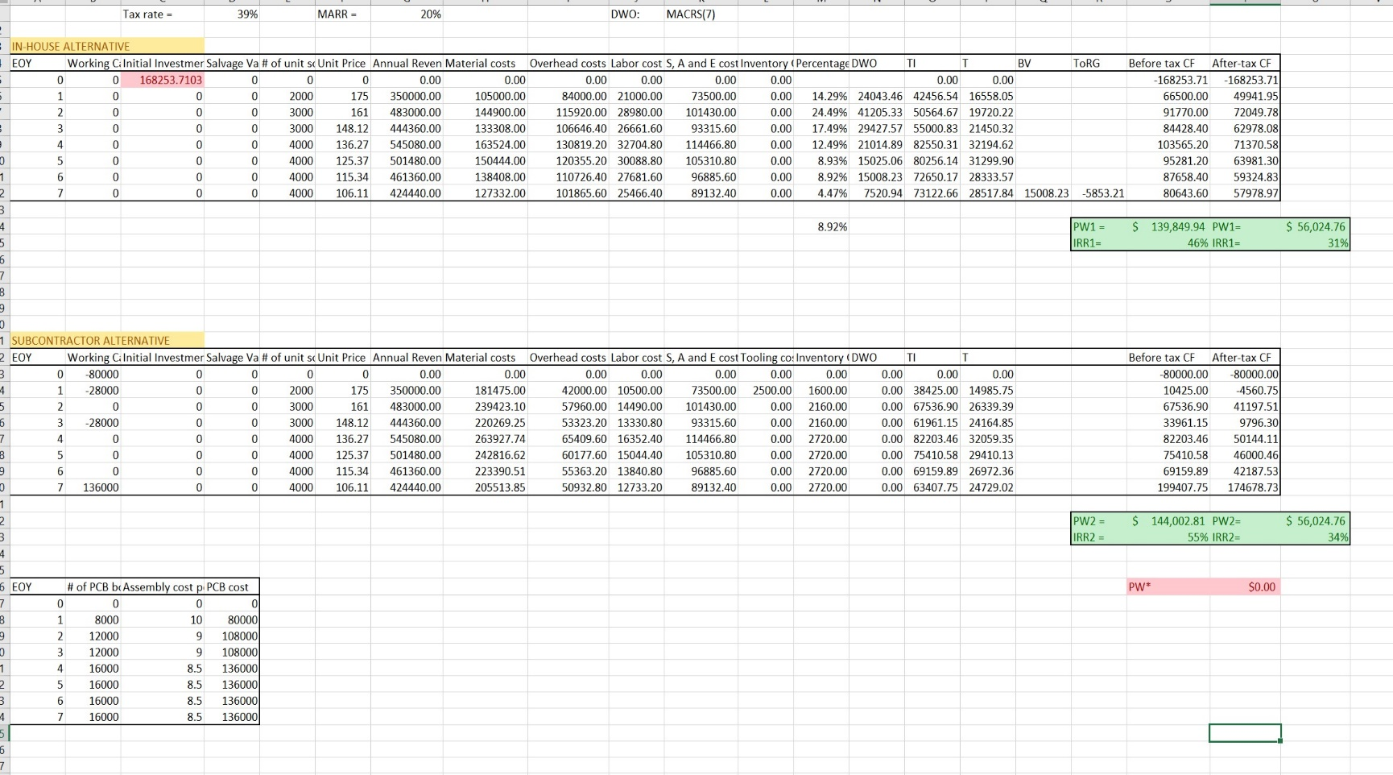

**Result:** By changing the initial investment of in-house option, we can make PW of in-house option equal to the PW of subcontracting option. After making PW equal for both alternatives, our initial investment for in-house alternative increases by **$ 112228.95**

2. What break-even equal annual demand would make the in-house option equivalent to the subcontracting option?

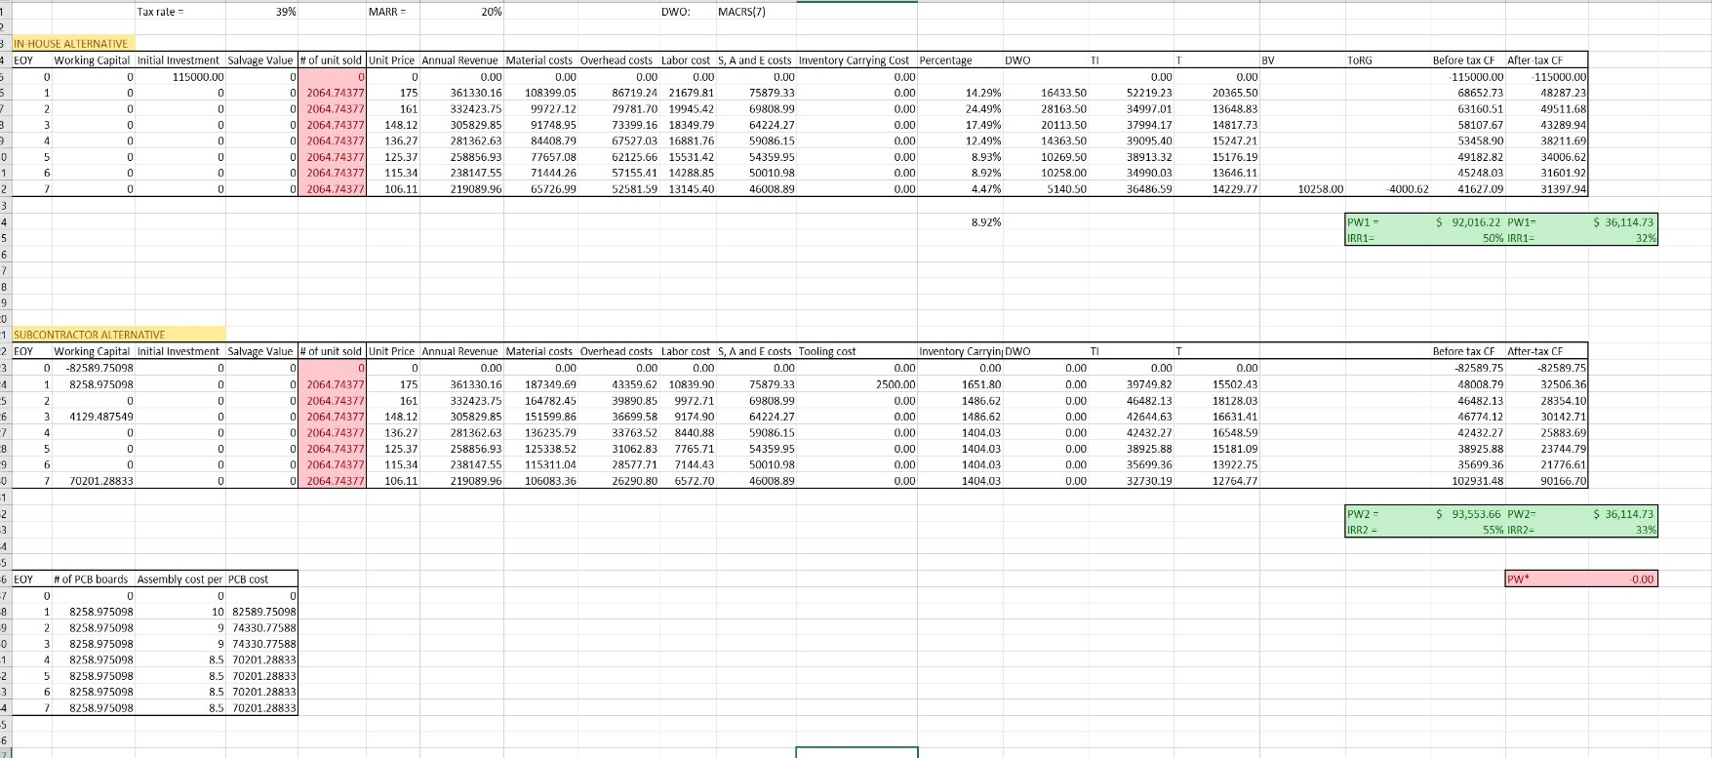

**Result:** By Break even analysis we can conclude that the equal annual demand should be **2065** units per year for the in-house alternative to be equivalent to the subcontracting alternative.

**CONCLUSION:**

From the overall result we found from Sensitivity analysis, break even analysis and from ATCF, we conclude that In- house option is more feasible than sub-contracting in most cases. But subcontracting alternative would be less deviant according to sensitivity analysis. However, we can choose worse case when we want minimum results in any case from best, worse and most likely in Sub-contracting option. We can make present worth of both alternatives equivalent by increasing initial investment of in-house production